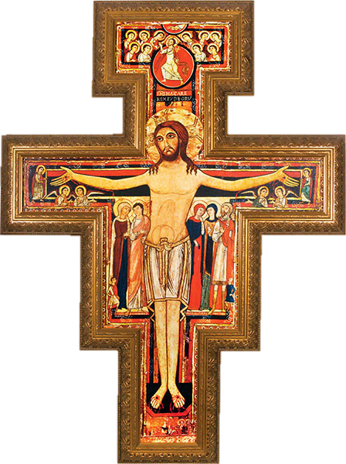
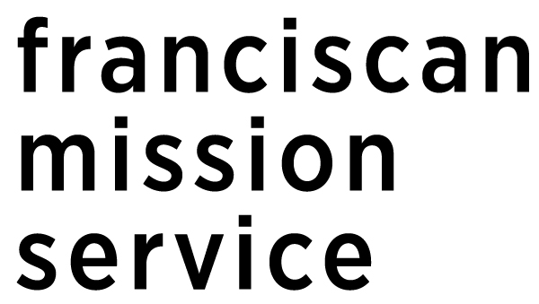

SAN DAMIANO
Servant Leadership Award

Deadline:
January 6th, 2019

DOWNLOAD THE APPLICATION
www.franciscanmissionservice.org/sd_award

Are you a young adult committed to
your faith and a life of service??
WHO SHOULD APPLY FOR THIS AWARD?

A COLLEGE JUNIOR OR SENIOR WITH:
- a commitment to values of Catholic Social Teaching
- a commitment to personal and communal faith life
- demonstrated leadership that engages others in service
- demonstrated service to marginalized or impoverished populations
- an ability to travel to Washington, DC the weekend of April 5, 2019

WHAT DOES THE WINNER RECEIVE?
- $500 scholarship
- Trip to Washington, DC on April 5 2019 with travel and accommodations provided
- Recognition at Franciscan Mission Service’s World Care Benefit on April 5, 2019
- Two meetings with professionals in the DC area working in areas of service or
social justice that the award recipient would like to learn more about

